**8-BIT DIVISION**

**EXP NO:4**

**AIM:** To write an assembly language program to implement 8-bit divison using 8085 processor.

**ALGORITHM:**

1. Start the program by loading the HL pair registers with address of memory location.
2. Move the data to B register.
3. Load the second data into accumulator.
4. Compare the two numbers to check carry.
5. Subtract two numbers.
6. Increment the value of carry.
7. Check whether the repeated subtraction is over.
8. Then store the results (quotient and remainder) in the given memory location.
9. Halt.

**PROGRAM**:

LDA 8501

MOV B,A

LDA 8500

MVI C,00

LOOP; CMP B

JC LOOP1

SUB B

INR C

JMP LOOP

LOOP1; STA 8502

MOV A,C

STA 8503

RST 1

**INPUT:**

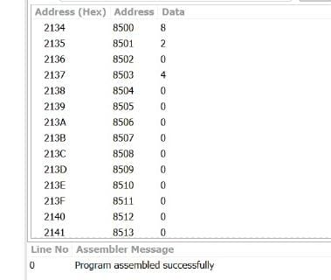

**OUTPUT:**

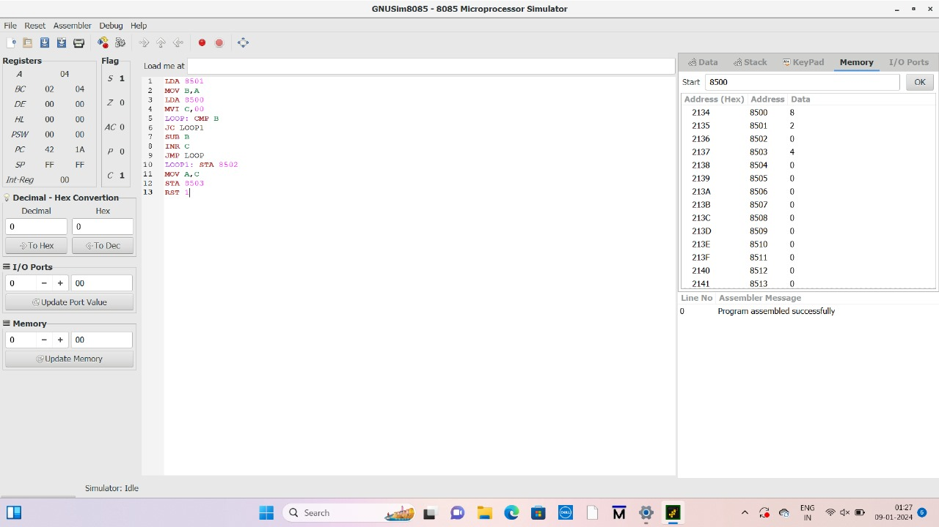

**RESULT:** Thus the program was executed successfully using 8085 processor simulator.